04.01 Graphical User Interfaces

Python GUI basics

Recall that GUI stands for Graphical User Interface. An interface is the boundary between two systems. We have written programs that have a character-based interface for input and output (this is not the editors used to create the programs, but the shell screen). We have also created graphics but strictly for output purposes.

A GUI allows the user to interact, provide input, with the program using graphical elements.

Similar to our graphics program, a GUI begins with a window. But instead of drawing images or shapes, whole visual elements or components also called widgets will be added to the window. (Note a canvas will not be needed here).

Since the purpose of any interface is to receive input from the user (in the form of data or commands), and to display output to the user, there needs to be widgets to perform these duties. Some common widgets in a windows-based GUI are buttons, labels and entry boxes.

Below is a simple example of a GUI.

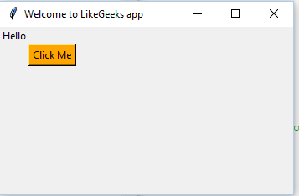

How to program the GUI
There are many development tools to program Python GUIs. We will continue to use the tkinter library.

Try in the Python Shell
The code below produces the minimum window

line 1: import tkinter

line 2: first_window = tkinter.Tk()

line 3: first_window.geometry(“500x500”)

line 4: fist_window.title(“First GUI”)

line 5: first_window.mainloop() #Moves control to the GUI window

Lines 1 – 5, inclusive, should be familiar.

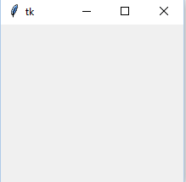
For a widget to be a window, it must have certain things, such as controls to minimize the window, maximize and exit. These are all behaviours you probably familiar with working on PCs.

These features are already fully defined in the tkinter library – programmers do not have to write the code to add minimize and maximize controls themselves. Python programmers need to know if a library exists somewhere with the functions, widgets, etc they need, and to know how to use them when writing code.

A convention for the course is all GUIs will be created as a maximum size of 700x700.

Creating and placing visual widgets

The window itself is a widget. So, it stands to reason that the code to create other widgets would be the same. That is, tkinter.**** where **** is the name of a widget to create.

For example,
first_label = tkinter.Label (first_window, text = “Hello”)

will create a Label, a widget that just displays a single line of text or string, and associates it to the window referenced by the variable “first_window”. The parameter “text” indicates that the text displayed in first_label will be “Hello”.

Other widgets that we will explore are Entry (for entry boxes), Button, Checkbutton, and Radiobutton.

But although a widget is “created” it must appear somewhere on the GUI window. A widget can be placed using the *.place () command, where * is the variable associated with the widget. Using the first_label example above the statement
first_label.place (x = 100, y = 80)
would place the label’s upper left corner at 100 pixels to the right and 80 pixels below the upper left corner of the window first_window. first_window is the widget that first_label is associated with (sometimes referred to as the “parent”). This relationship was established when the label was created using
first_label = tkinter.Label (first_window, text = “Hello”)

There are other parameters in *.place () but x, and y are the most straight forward.

Try.
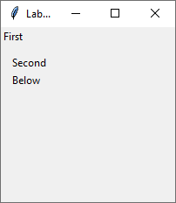
Create three labels, with the texts “First”, “Second” and “Below”, respectively, and place them so they are in positions (0, 0), (10, 30) and (10, 50), respectively. It should look as to the right.

Although the words looks like pixel graphics using the create_text () command, this is a GUI window and is very different.

Check your code with “04.01_examples_labels.py”.

Try.
Modify the above example, 04.01_examples_labels.py and create a fourth label with the text “Fourth” and try to place it in grid position (10, 40). What happened?
This new label can be seen as overlapping the previous two labels. The GUI window should be designed first, and placement of widgets planned out so they do not overlap.

Some common visual characteristics (or parameters) of widgets are given below, along with their defined values. Set these values when creating the widget.

bg  (for background) | "white", "black", "red", "green", "blue", "cyan", "yellow", and "magenta"
fg  (for foreground) | same as bg
font | “Helvetica”, “Times”, “Arial”, “Century”  (Note: I’ve only tested these)
weight | “bold”, “normal”  (Note: May not work anymore)
wraplength
limit the length of a line by specifying the number of characters in one line

For example,

first_label = tkinter.Label(first_window, text="First", fg="white", bg=”blue”)

will create a label with the foreground colour set to white, and the background colour to blue.

Exercises 04.01 GUI programming

04.01.01
Create a GUI, with a fixed size. Create and place 4 labels, with the numbers “1”, “2”, “3” and “4”, and arrange as :
- all labels with x = 0, different y values
- all labels with y = 0, different x values

04.01.02
Some other placement parameters can be used instead of x and y. Modify 04.01_example labels.py by keeping the first label (at (0, 0)) and replacing the rest with:
- Create and place a second label as *.place (relheight=0.5, relwidth=0.5)
Run the program. Grab the lower right corner of the window and resize the window in different directions.
- Add to a) a third label as *.place (relx – 0, rely = 0.7) and run and resize.
The two new parameters use relative or proportional settings, and take a value between 0.0 and 1.0

04.01.03
Create a GUI program that allows the user to enter a phrase, and a desired font (you can try to find others, or just stick with the four listed), and have that phrase appear in a label, in the indicated font.

